
LESSON NOTE | DETAILED EXPLANATORY NOTES
ECOLOGY & EVOLUTION
POPULATION DYNAMICS, SAMPLING & GROWTH MODELS

GRADE 12 - BIOLOGY
■ ■ ■

How Populations Change
A population is all the organisms of the same species living in the same area at the same time. Population dynamics is the study of how the size of a population change over time - growing, shrinking or staying steady - and what causes those changes. To study populations, ecologists must estimate their size using sampling methods, and they use mathematical models to describe and predict growth.
This lesson explains how populations grow (the exponential J-curve and logistic S-curve, and carrying capacity), how scientists sample populations (quadrats and mark–recapture), and the factors that control population size. It is an important part of the Ecology & Evolution strand.
Why This Matters
- Population size affects the whole ecosystem and its balance.
- Sampling lets us estimate numbers we cannot count directly.
- Growth models predict how populations will change.
- It underpins conservation, farming, fishing and pest control.
Population Dynamics / Sampling / Growth Models
Key Learning Outcomes
By the end of this lesson, students should be able to:
- Define a population and explain what changes its size.
- Describe exponential (J) and logistic (S) growth and carrying capacity.
- Use quadrat and mark–recapture sampling to estimate population size.
- Explain density-dependent and density-independent factors.
- Apply these ideas to real situations, including in Papua New Guinea.
Population Growth Models
Populations tend to grow in one of two patterns. In exponential growth, a population grows faster and faster with no limits, producing a J-shaped curve - this happens when resources are unlimited, for example when a species first enters a new area. In reality, resources run out, so growth usually follows logistic growth, an S-shaped curve: growth is rapid at first, then slows and levels off at the carrying capacity (K) - the maximum population the environment can support. Once at K, births and deaths roughly balance, and the population stays fairly steady.
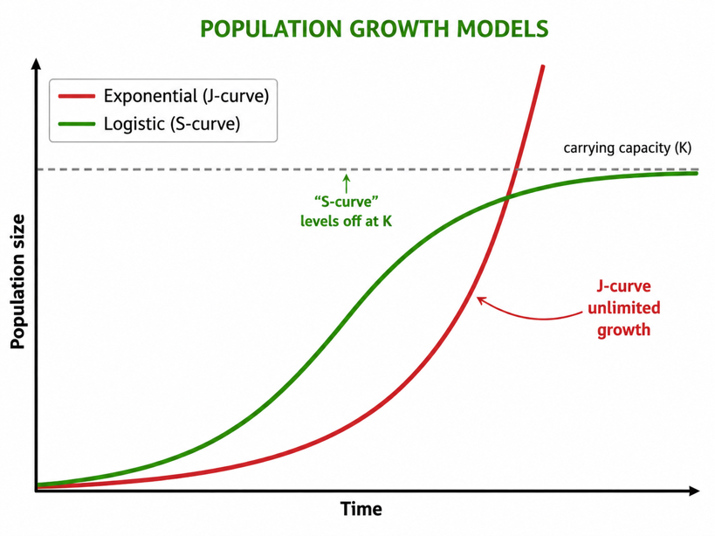
Figure 1: Population growth models - the exponential J-curve and the logistic S-curve, which levels off at the carrying capacity (K).
Terminologies and Concepts
Useful terms for this topic:
- Population: all the members of one species in an area at one time.
- Exponential (J) growth: unlimited growth that speeds up over time.
- Logistic (S) growth: growth that slows and levels off at a limit.
- Carrying capacity (K): the maximum population the environment can support.
- Quadrat: a square frame used to sample organisms in a set area.
- Mark–recapture: a method to estimate the size of a mobile animal population.
- Density-dependent / -independent: factors that depend on / ignore population size.
Sampling - Estimating Population Size
It is usually impossible to count every organism, so ecologists sample and then scale up. For plants and slow organisms, a quadrat - a square frame of known area - is placed randomly several times; the organisms inside are counted and the average is scaled up to the whole habitat. For mobile animals, the mark–recapture method is used: a number of animals are caught, marked and released; later a second sample is caught, and the proportion of marked animals in it is used to estimate the total population. Both methods rely on taking random, representative samples.
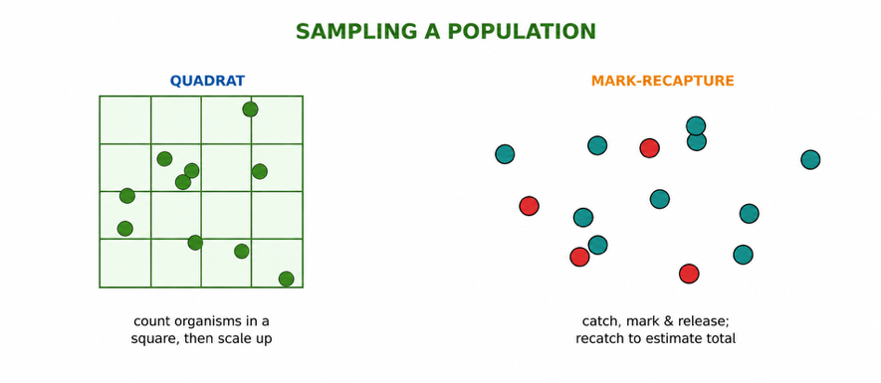
Figure 2: Sampling methods - quadrats for fixed organisms and mark–recapture for mobile animals.
Worked Example - Mark–Recapture
Suppose 20 fish are caught, marked and released. Later, 25 fish are caught and 5 of them are marked. The total population is estimated by:
N = (first marked × second sample) ÷ number recaptured
So, N = (20 × 25) ÷ 5 = 100 fish. The method assumes the marked animals mixed back in fully and that none were born, died, or moved in or out between the two catches - a good estimate when those assumptions roughly hold.
Factors That Control Population Size
Populations do not grow forever; they are held in check by limiting factors, grouped into two kinds. Density-dependent factors have a stronger effect when the population is crowded - these include food and water supply, disease, predators and competition. As a population grows, these factors push back harder, tending to hold it near the carrying capacity. Density-independent factors affect a population regardless of its size - mainly weather, climate and natural disasters such as fire, drought or floods. Together, these factors make populations rise and fall over time.
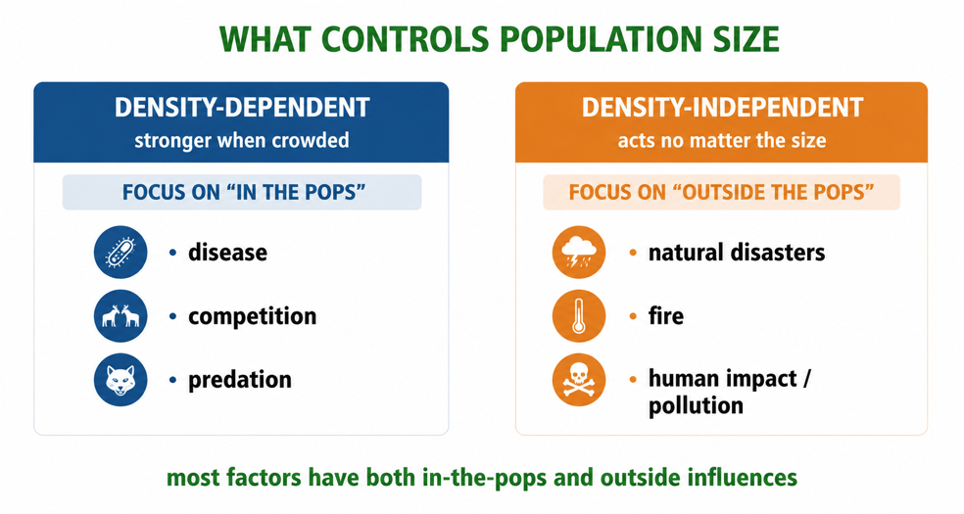
Figure 3: Density-dependent and density-independent factors that control population size.
Why This Matters
- Conservation - knowing population trends helps protect endangered species.
- Fishing and farming - sustainable harvests depend on population models.
- Pest control - understanding growth helps manage pests and diseases.
- Human population - the same ideas apply to human population growth.
PNG Context Example
Population dynamics matter greatly in Papua New Guinea. Fisheries - such as tuna and reef fish - must be managed so that catches stay within the population's carrying capacity, or stocks collapse; mark–recapture and other sampling methods help monitor them. Conservation of threatened species like the tree kangaroo and birds of paradise relies on estimating their populations and understanding limiting factors such as habitat loss and hunting. Pest and disease outbreaks (for example malaria-carrying mosquitoes, or crop pests) also follow population-growth patterns. These tools help PNG manage its natural resources sustainably.
References & Related Documents
Source Documents
- Biology Standards-Based Syllabus, Grades 11 & 12 (PNG SBC 2020) - Strand: Ecology & Evolution; investigate population size, growth and the factors that regulate populations, using sampling methods.
- STEM Biology Syllabus - Grade 12. Thema: Ecology; Module: Populations and Ecosystems. Department of Education, PNG.
Further Reading & References
- OpenStax Biology - Population Demography; Population Growth and Regulation. https://openstax.org/books/biology
- Khan Academy - Population ecology; exponential and logistic growth. https://www.khanacademy.org/science/biology/ecology

